Комунальний заклад освіти
«Спеціалізована школа №115»
Дніпропетровської міської ради

Тиждень англійської мови
12.12.2016 – 16.12.2016

Тиждень англійської мови
12.12.2016-16.12.2016

12.12.2016 – Конкурс проектних робіт у 10 класі
на тему : «Меню мого ресторану»

13.12.2016 – Конкурс проектних робіт між учнями 8х класів
на тему : «Шкільна газета»

14.12.2016 – Вистава лялькового театру:
1) казка «Колобок» (5А клас, 1 урок)
2) казка «Маленька червона курочка» (5А клас, 2 урок)
3) казка «Маленький будиночок» (5А клас, 3 урок)
Вчитель: Кугно Надія Володимирівна

15.12.2016 – 1) Брейн – ринг між учнями 3х класів (3 урок)
Вчителі: Кугно Надія Володимирівна
Богдан Ірина Олександрівна
2)Відкритий урок з англійської мови на тему :
«Здоров’я – найцінніший скарб» (4 урок)
Вчитель: Іваниця Валентина Ігорівна

16.12.2016 – Конкурс проектних робіт між учнями 7х класів
на тему : «Медицина»
Позакласний захід у 8А класі
на тему: «Ромео і Джульєта»
Вчитель : Крохмаль Любов Іванівна

Інсценізація казки «Колобок» учнями 5-А класу

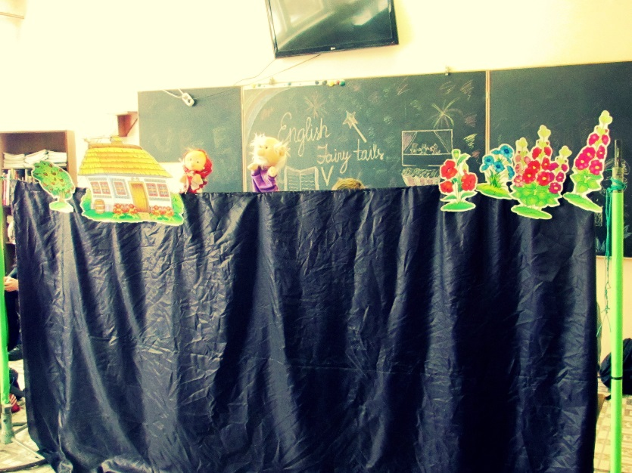
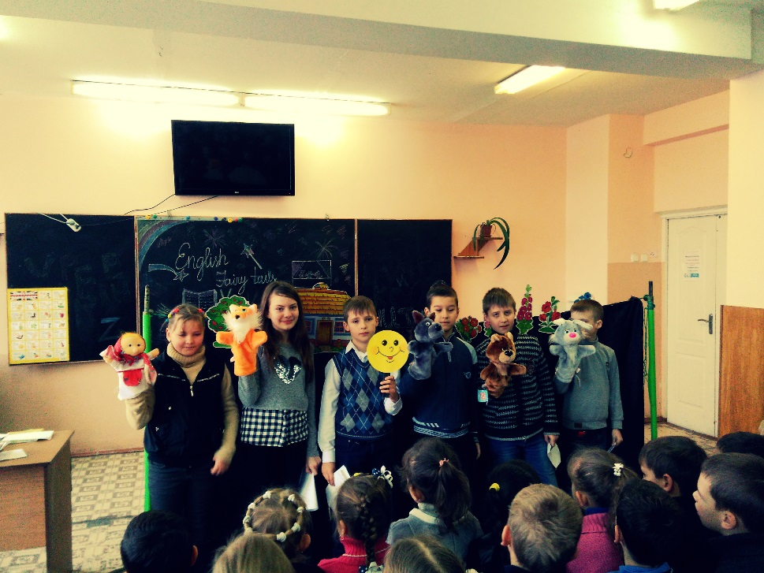
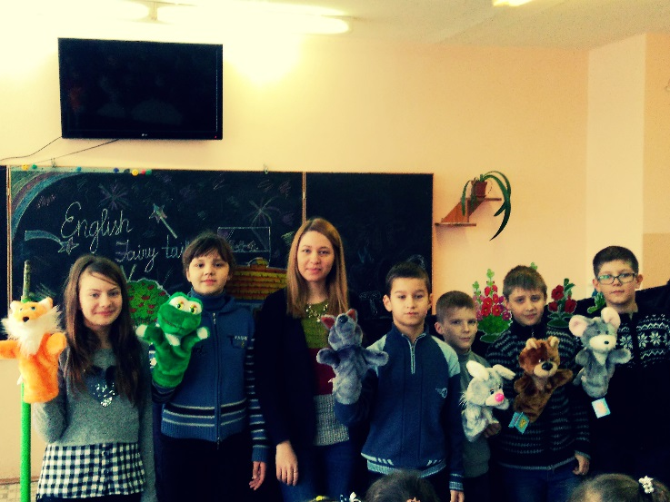
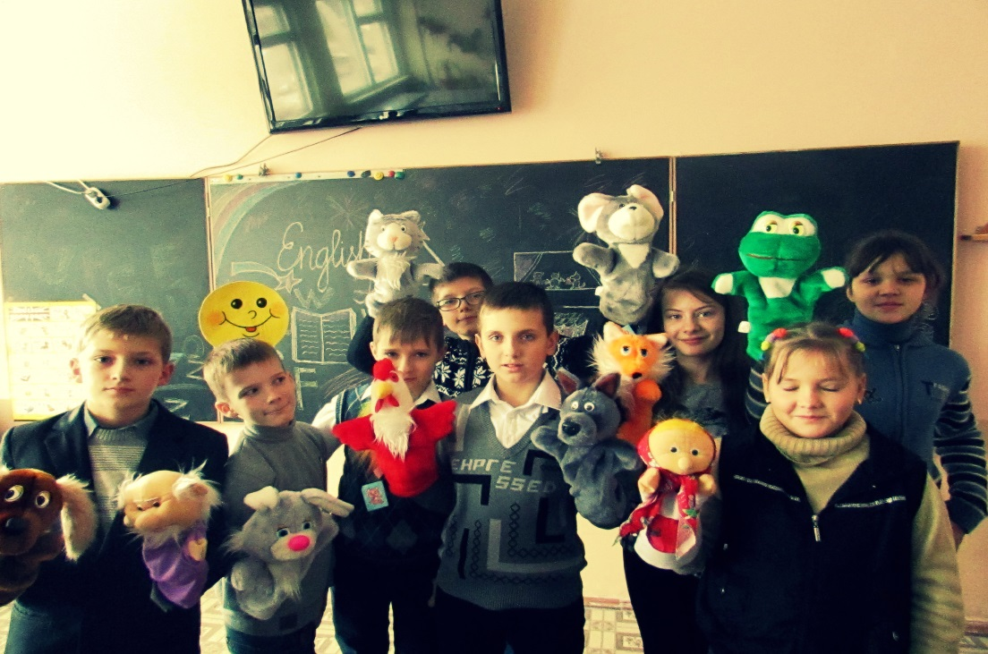

Інсценізація казки «Маленька червона курочка»
учнями 5-А класу
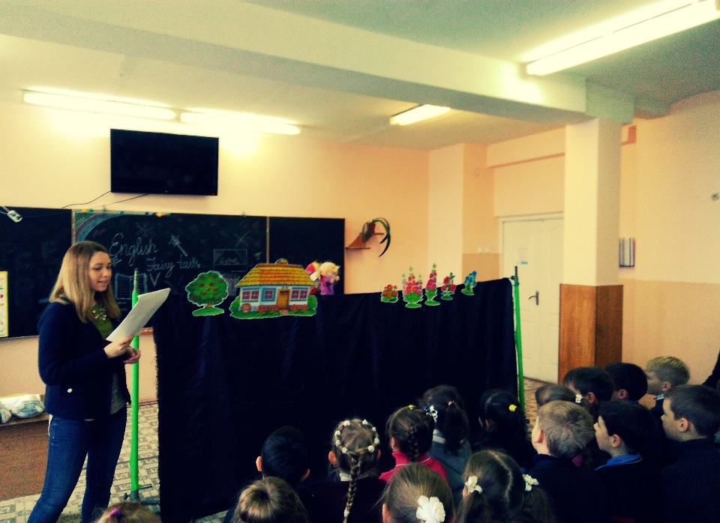
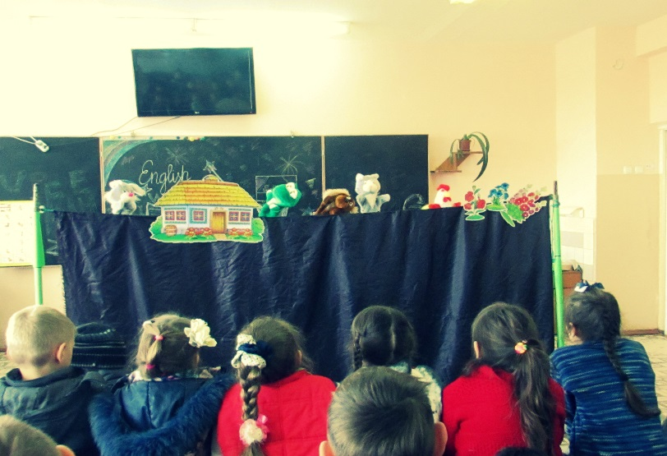

Інсценізація казки «Теремок» учнями 5-А класу

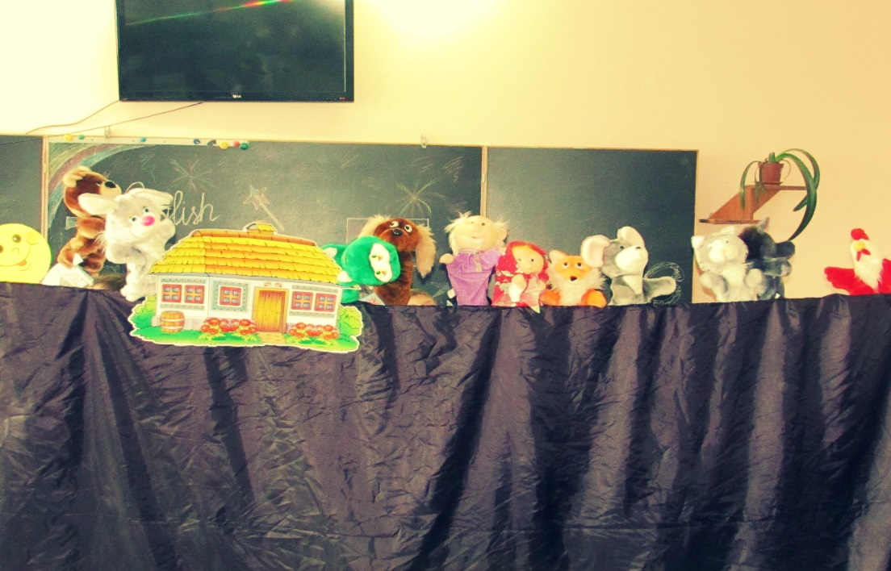
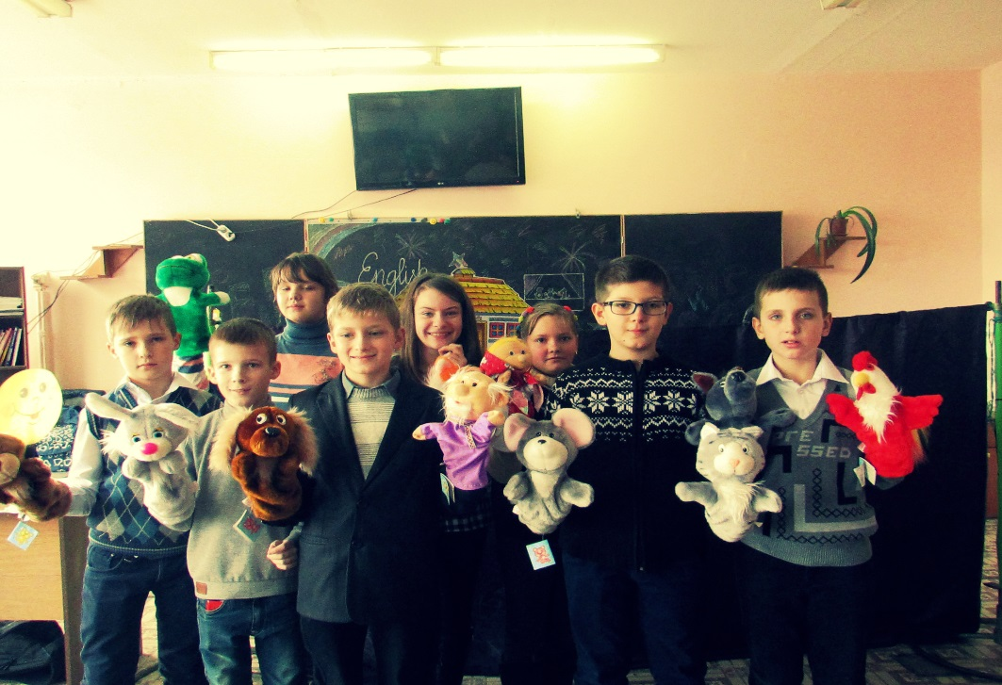
A ROLL
Characters:
An Author
A Grandfather
A Grandmother
A Roll
A Hare
A Wolf
A Bear
A Fox
Scenery:
A big old oven, a table, a bench and a window.
Trees, flowers and bushes.
A stump.
AN AUTHOR: Long, long time ago, once upon a time somewhere about there lived the grandfather and the grandmother. They lived happily and friendly in a very old house. The grandpa and the grandma liked to work hard and sing songs.
Singing:
A GRANDPA: Oh, it is so nice just simply live, yap.
A GRANDMA: Oh, enjoy the sky forget the grieve, yap.
A GRANDPA: Enjoy the honey drink and tea,
A GRANDMA: To eat sweet buns without plea.
AN AUTHOR: After singing the song the grandpa decided to ask the grandma to bake some roll.
A GRANDPA: Sweaty, can you bake some roll for us?
A GRANDMA: I would like to, but there is no more flour left.
A GRANDPA: Can you wipe the shelves carefully; maybe there you will find one or two scoops of flour.
AN AUTHOR: The grandma did what the grandpa asked her to do. Carefully wiped all shelves and finally found two scoops of flour. She made dough based on sour cream, formed a roll and put it in the oven for baking. The grandpa is singing a song, the grandma is singing along.
(Kids can show what they are doing during the song.)
A GRANDPA: We decided to bake the roll, to bake the roll, to bake the roll. (Make the roll).
A GRANDMA: We decided to bake the roll, to bake the fresh puffy roll.
A GRANDPA: We invited boys and girls, boys and girls, boys and girls. (Waving hands towards themselves).
A GRANDMA: We invited boys and girls, to eat our puffy roll.
A GRANDPA: Boys and girls ate our roll, our roll, our roll. (Show how they are eating the roll).
A GRANDMA: They became all tall and strong, tall and very strong.
A GRANDPA: They said, thank you and goodbye, and goodbye, and goodbye. (Waving hands "bye, bye").
A GRANDMA: See you grannies, please don't cry, please don't cry. (Show how they are crying).
A GRANDPA: We will visit you again hug and kiss you, hug and kiss you. (Sending kisses).
A GRANDMA: We will visit you again, please don't miss us, please don't miss us.
AN AUTHOR: When the roll was ready, the grandma took him from the oven and placed on the windowsill.
A GRANDMA: Look, grandpa, how lovely our roll is.
A GRANDPA: It is lovely.
AN AUTHOR: Agreed the grandpa. The roll heard everything what the grandma and the grandpa said about him and so he became very proud. After some time the roll was bored to lie on the windowsill. Nobody said anything nice about him anymore, so the roll decided to jump outside and have a look, what is going on around.
A ROLL: Maybe somebody else will notice how unique I am!
AN AUTHOR: The roll was thinking while rolling into the forest. Here is the hare going towards the roll.
A HARE: Hi, little roll, I am going to eat you!
A ROLL: Don't eat me hare, I will sing you a wonderful song.
AN AUTHOR: And the roll started to sing the song.
A ROLL: I'm the roll, roll, roll,
Made from flour round ball,
Made from sour cream and milk,
I'm shiny like silk.
I am running from grandma,
I am running from grandpa.
To the forest far away
Catch adventure day by day.
And from you, little hare, I will easy run away.
AN AUTHOR: The hare even didn't notice the roll disappear.
A HARE: What a wonder! He has just been here and somehow he is gone...
AN AUTHOR: The roll was rolling along the wooden path, enjoying the bright sunny day. The roll stopped and noticed somebody coming.
A WOLF: Hi, tasty roll, I'm going to eat you.
AN AUTHOR: Said the hungry, homeless wolf.
A ROLL: Don't eat me, Mister wolf, I will sing you a song.
A WOLF: Ok, ok, just quickly, I am really hungry!
AN AUTHOR: The roll started singing his song.
A ROLL: I'm the roll, roll, roll,
Made from flour round ball,
Made from sour cream and milk,
I'm shiny like silk.
I am running from grandma,
I am running from grandpa.
I am running from the hare
I like running I'm not tired.
To the forest far away
Catch adventure day by day.
And from you, Mister wolf, I will easy run away.
AN AUTHOR: The wolf looked around, but the roll was far away. He hopelessly licked his mouth.
A WOLF: Unbelievable! I didn't bite even a small piece of that tasty roll. U-u-u-u he is very smart! Next time I'm not going to listen to any stupid songs; I will bite and eat, eat and eat.
AN AUTHOR: And the wolf started gnashing with his sharp teeth. But the roll happily kept running deeper to the forest. The roll was running, running and saw the big brown bear approaching him.
A BEAR: R-r-r, hi, round crunchy bread, I'm going to eat you.
A ROLL: I am not simply bread; I am a roll.
AN AUTHOR: Said proudly the roll.
A BEAR: It's so nice to meet you, roll.
A ROLL: Don't eat me please, big brown bear, I will sing you a song.
A BEAR: Oh, so kind, and so romantic, dinner after performance.
AN AUTHOR: The bear sat down under the tree, closed his eyes and became ready to listen to the song. The roll started singing.
A ROLL: I'm the roll, roll, roll,
Made from flour round ball,
Made from sour cream and milk,
I'm shiny like silk.
I am running from grandma,
I am running from grandpa.
I am running from the hare
I like running I'm not tired.
I am running from the wolf
I have got my own rule.
To the forest far away
Catch adventure day by day.
And from you, big brown bear, I will easy run away.
AN AUTHOR: The big brown bear was still waiting for another song, but the roll went on his way.
A BEAR: R-r-r-r!
AN AUTHOR: Growled bear.
A BEAR: He cheated me!? I'm silly; I'm fool! And I am still hungry! Well, little cheater, don't meet me again; otherwise I will swallow you without saying anything, just "um, um"!!! And that's it!
AN AUTHOR: The angry bear went to the deep forest and disappeared. The roll is rolling proud of himself, thinking how smart and cleaver he is and everybody around is so fool. The roll was rolling, rolling and suddenly ran into the fox.
A FOX: Hello, dear! I have never seen anybody so beautiful and smart as you are! You are perfect!!! You are adorable!!! I like you so much!!!
AN AUTHOR: And the fox licked her mouth.
A ROLL: Hi, red fox, do you want me to sing you the song, I wrote myself!
AN AUTHOR: Boasted the roll more and more.
A FOX: Of course, I want to.
A ROLL: I'm the roll, roll, roll,
Made from flour round ball,
Made from sour cream and milk,
I'm shiny like silk.
I am running from grandma,
I am running from grandpa.
I am running from the hare
I like running I'm not tired.
I am running from the wolf
I have got my own rule.
I am running from the bear
I want find my luck somewhere!
To the forest far away
Catch adventure day by day.
And from you, red fox, I will easy run away.
A FOX: What a wonderful song!
AN AUTHOR: The fox pretended to be crying.
A FOX: Poor me, I became so old, so unhappy, I can't hear properly anymore. Don't you mind sitting down on my nose and singing your magic song for me again?
AN AUTHOR: The roll was so amazed and charmed by the red fox, so he forgot about any danger.
A ROLL: Of course, I will.
AN AUTHOR: The roll jumped on top of the red fox nose and started singing his song.
A ROLL: I'm the roll, roll, roll….
AN AUTHOR: But the red fox "um"! And ate him.
Here is the end of the story, to them who carefully listened honour and glory!!!

The Little Red Hen

Hen
Dog
Cat
Duck
Chicks

Hen: Hello! I'm a hen. I've got three friends.
Dog: Bow-wow-wow! Hello! I'm a dog.
Cat: Meow! Hello! I'm a cat.
Duck: Quack-quack! Hello! I'm a duck.
Hen: And I've got little yellow chicks.
Chicks: Hello!
Hen: Look! I've got five seeds. One, two, three, four, five.
Hen: I want to plant the seeds. Can you help me?
Dog: No, I can't. I want to run.
Cat: No, I can't. I want to play with a mouse.
Duck: No, I can't. I want to swim.
Hen: Can you help me, chicks?
Chicks: Yes, we can!
Hen: All right, let's go.
Hen: I want to water the plants. Can you help me?
Dog: No, I can't. I want to jump.
Cat: No, I can't. I want to climb.
Duck: No, I can't. I want to fly.
Hen: Can you help me, chicks?
Chicks: Yes, we can!
Hen: All right, let's go.
Hen: Now I want to make a cake. Can you help me?
Dog: No, I'm tired. I want to sleep.
Cat: No, I'm tired. I want to sleep, too.
Duck: No, I'm tired. I want to sleep very much.
Hen: Can you help me, chicks?
Chicks: Yes, we can!
Hen: All right, let's go.
Hen: Now it's time to eat the cake.
Dog: Oh, a cake! I'm hungry!
Cat: I'm hungry, too!
Duck: I'm very hungry!
Dog, Cat, Duck: Can we eat the cake?
Hen: No, you can't.
Dog: And who will eat the cake?
Hen: My chicks will eat the cake. They always help me.

The Little House

Mouse
Frog
Rabbit
Fox
Wolf
Bear
Mouse: Oh! What a nice house! (стучит) …Knock-knock! …Who lives in the house?(заглядывает внутрь) … Nobody! I think I'll come in.
Frog: Knock-knock! Who lives in the house?
Mouse: Hello, I'm a mouse.
Frog: Hello, I'm a frog. May I live in your house?
Mouse: Yes. Come in, please.
Rabbit: Knock-knock! Who lives in the house?
Mouse: Hello, I'm a mouse.
Frog: Hello, I'm a frog.
Rabbit: Hello. I'm a rabbit. May I live in your house?
Mouse, Frog: Yes. Come in, please.
Fox: Knock-knock! Who lives in the house?
Mouse: Hello, I'm a mouse.
Frog: Hello, I'm a frog.
Rabbit: Hello. I'm a rabbit.
Fox: Hello, I'm a fox. May I live in your house?
Mouse, Frog, Rabbit: Yes. Come in, please.
Wolf: Knock-knock! Who lives in the house?
Mouse: Hello, I'm a mouse.
Frog: Hello, I'm a frog.
Rabbit: Hello. I'm a rabbit.
Fox: Hello, I'm a fox.
Wolf: Hello, I'm a wolf. May I live in your house?
Mouse, Frog, Rabbit, Fox: Yes. Come in, please.
Bear: Knock-knock! Who lives in the house?
Mouse: Hello, I'm a mouse.
Frog: Hello, I'm a frog.
Rabbit: Hello. I'm a rabbit.
Fox: Hello, I'm a fox.
Wolf: Hello, I'm a wolf.
Bear: And I'm a big Bear. May I live in your house?
Mouse: Oh, no!
Frog: You are too big!
Rabbit, Fox, Wolf: You can't live in the house!
Animals: Help, Help!

Вчителі : Богдан Ірина Олександрівна
Кугно Надія Володимирівна

«WHAT? WHERE? WHEN?»
Позакласний захід
з англійської мови

Брейн-ринг «WHAT? WHERE? WHEN?»
між учнями 3-іх класів
Вчителі: Богдан Ірина Олександрівна
Кугно Надія Володимирівна
Мета: перевірити та показати компетентності учнів у читанні, перекладанні, розумінні запитань, та вмінні давати відповіді на них; розвивати пам’ять, мислення, увагу, уміння реагувати в проблемній ситуації; виховувати інтерес, почуття відповідальності та бажання спілкуватися англійською мовою.
Обладнання: конверти із запитаннями, плакати, емблеми, годинник, дзиґа.
Хід проведення заходу.
У класній кімнаті дві команди – «Wunderkinds» та «Champions» - розташовуються за своїми ігровими столами. У кожній команді по вісім гравців. Кожна команда має капітана та відповідну емблему.
Teacher: Good afternoon dear friends! Glad to see you! You are welcome to our competition between «Wunderkinds» and «Champions». (Добрий день, дорогі друзі! Раді вас бачити. Запрошуємо на конкурс-змагання між командами «Wunderkinds» and «Champions».)
Dear captains! Introduce your teams and the members of your team. (Капітани! Відрекомендуйте нам членів ваших команд.) P1 I am Max Yerinenko and this is my team.
The team: Wunderkinds. (хором)
P1 Now I want to introduce you the members of my team. The first player is… (Зараз я хочу представити гравців своєї команди. Перший гравець, це… (далі називає всіх членів команди.))
P2 I am Illia Stetsurenko. Let me tell you the member of my team. The first player is…
Teacher: Thank you! Take your seats please. (Дякую. Займіть свої місця, будь ласка.) Let me introduce our judges. Here they are…(Дозвольте мені представити наших суддів. Ось вони…)
Teacher: And now it is high time to begin our competition. First of all we want to know if you can answer the questions.
Dear players! Are you ready to start? Ok! (А зараз розпочинати час наше змагання. Передовсім ми хочемо дізнатися, чи вмієте ви відповідати на запитання. Гравці ви готові розпочинати гру?Гаразд.
Look at the symbol of our game? What is it, children?
Children: Owl.
(Подивіться на символ нашої гри, Що це, діти? – Сова.)
Учитель запускає дзиґу, стрілка зупиняється на секторі №12. Учитель бере конверт, повідомляє хто грає і з якого міста(села) прийшло це завдання, а потім читає вголос запитання. Подається сигнал дітям надається хвилина на підготовку відповіді. Через хвилину учасник від команди дає відповідь. Якщо відповідь правильна – команда отримує бал, а якщо ні то інша команда дає відповідь.
Questions:
- Скільки букв в англійському алфавіті? Назвіть їх. (26)
- Як називається 15 літера англійського алфавіту?(О)
3. Складіть та запишіть якомога більше слів на букву “P”.
4. Які форми привітання ви знаєте англійською мовою?(Hello!Hi!)
5. Перекладіть якнайбільше слів на українську мову.
a fox, an apple, a ball, a rabbit, a hen, a girl, a desk, a lamp, milk, green, yellow, blue, ten, six, a dress, a pen, a family, a brother, a sister, a door, a cat, a floor, a flat, a doctor, a pencil, children, a car, a scarf, a bench.

An apple, a bird, winter, fish, a sock, a mother, a father, a cat, black, big, little, bad, a bus, a plum, a town, three, seven, a scarf, a letter, she, a drum, a flat, a desk, a cap, a cup, a kitchen, a box, I, they.
6. Розшифруйте речення.
Ihaveabigfish. Itisabadpencil-box. Thischerryisred. Wehaveabigbox.
Theyhaveadog.
7. Заспівайте англійську пісню.

8. Доберіть до малюнків слова. Rabbit, frog, squirrel, cock, puppy, kitten.
9. Складіть якомога більше речень англійською мовою.
There is a kitten in the yard.
There are seven pencils in the pencil box.
There is a duck on the pond.
There are nuts on the desk.
10. Заповни кросворд та намалюй відповідь.
Teacher: What account do we have now? Congratulation. We have the score ,
but I think that friendship has won. Do you agree with me? Each team had wonderful answers and played very well. I would like to thank our teams, and give this present for you.
Dear judges I would like to thank you for your work too.
Our game “What? Where? When?” is over.

(Який рахунок зараз? Вітаємо у нас рахунок , але я вважаю, що перемогла дружба. Ви згодні зі мною? Кожна команда давала чудові відповіді і грала чудово. Я хочу подякувати вам і вручити ці подарунки. Дорогі судді! Я хочу також подякувати вам за вашу роботу. На цьому наша гра завершена.)

Відкритий урок у 7-Б класі
«Здоров’я – найцінніший скарб»
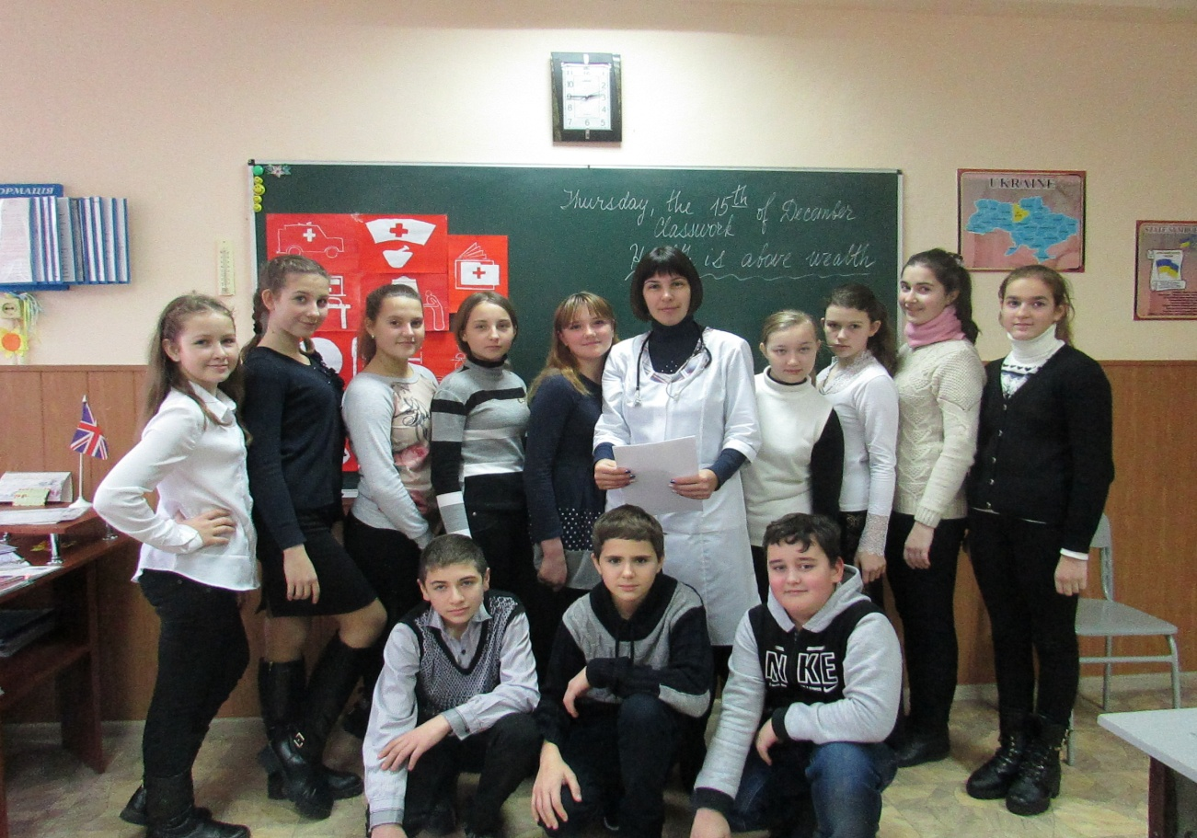

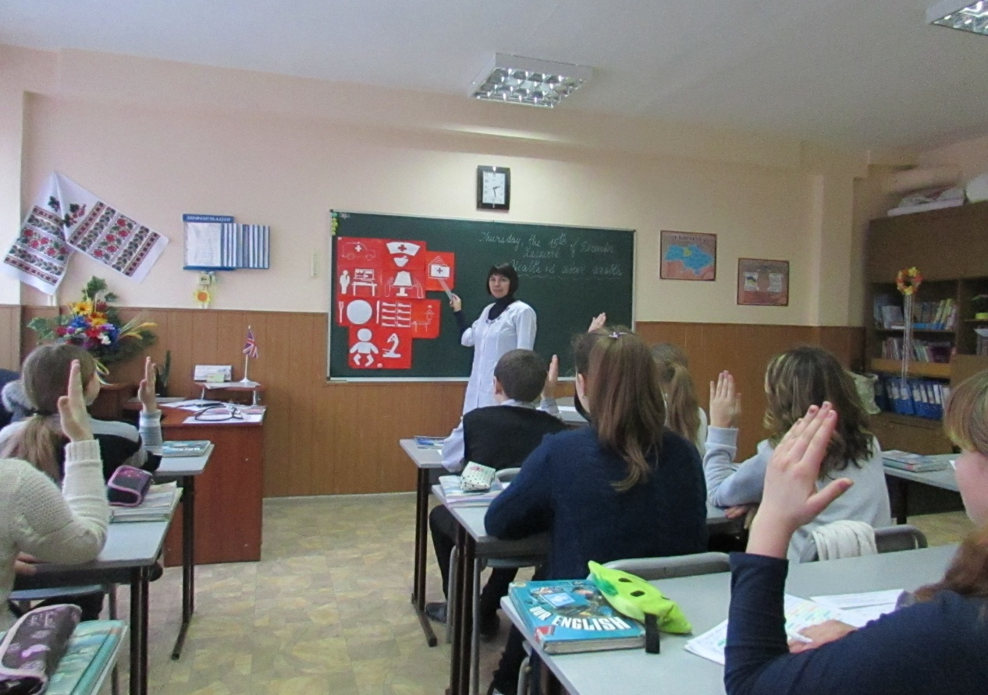
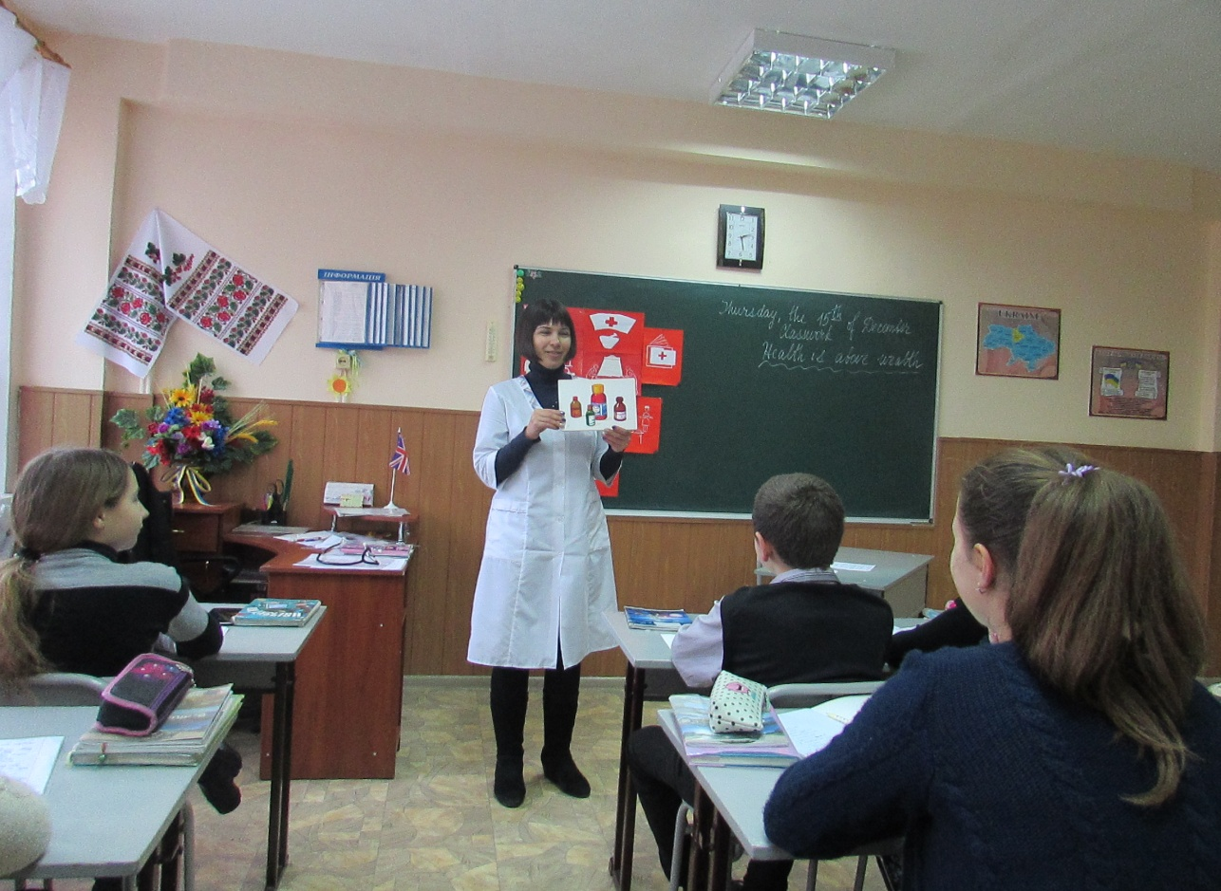

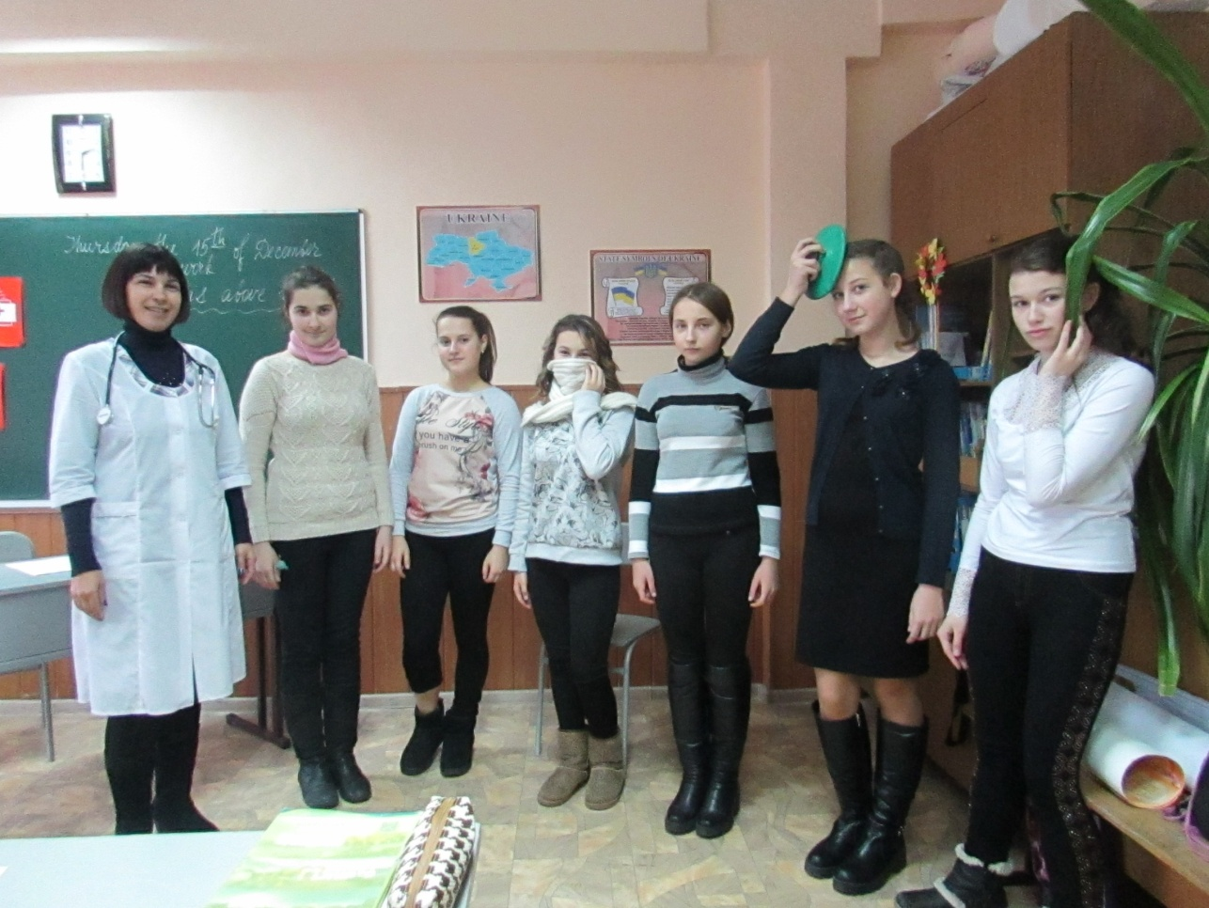

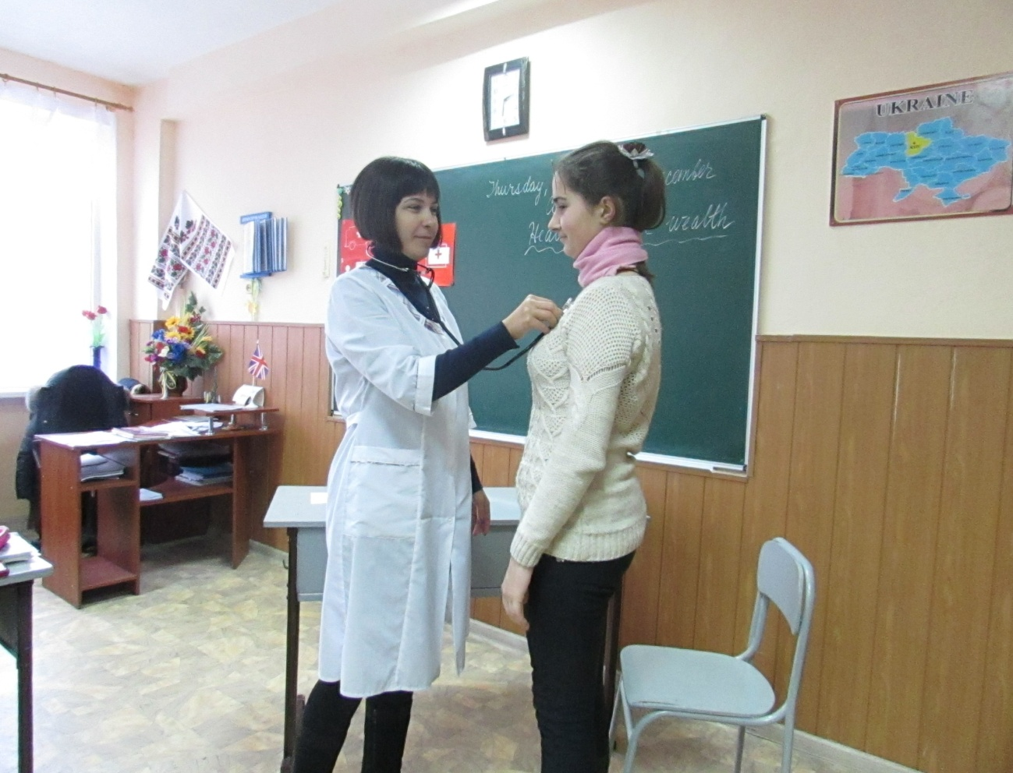
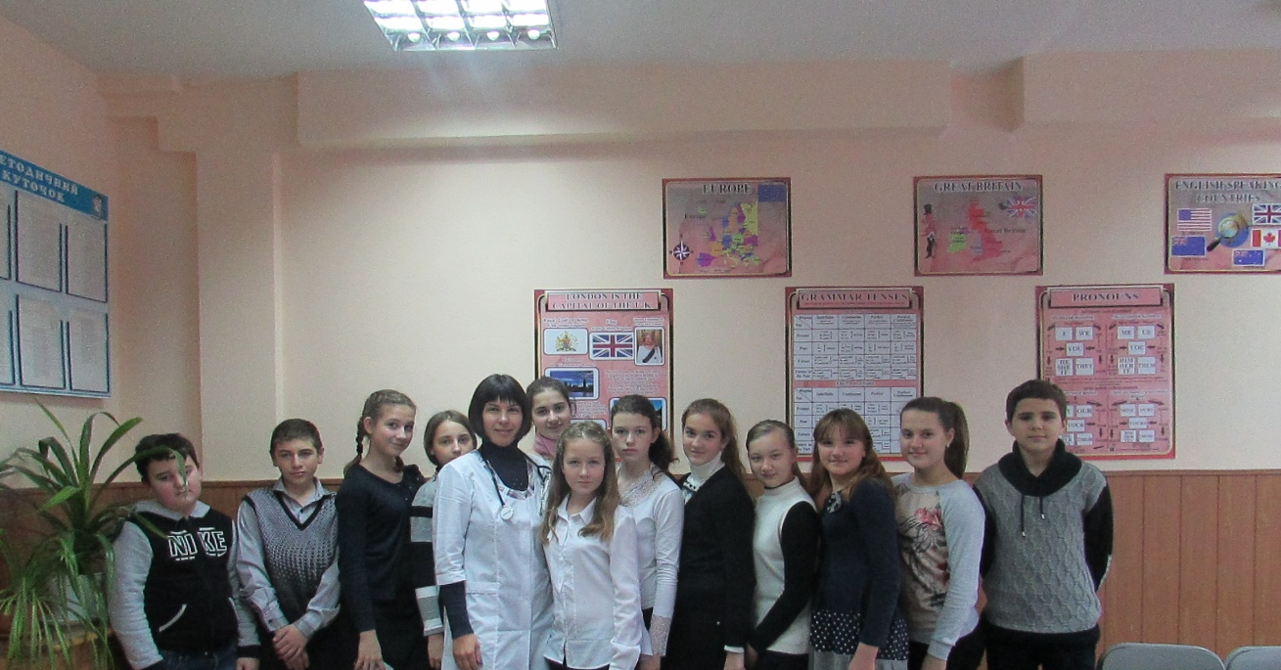

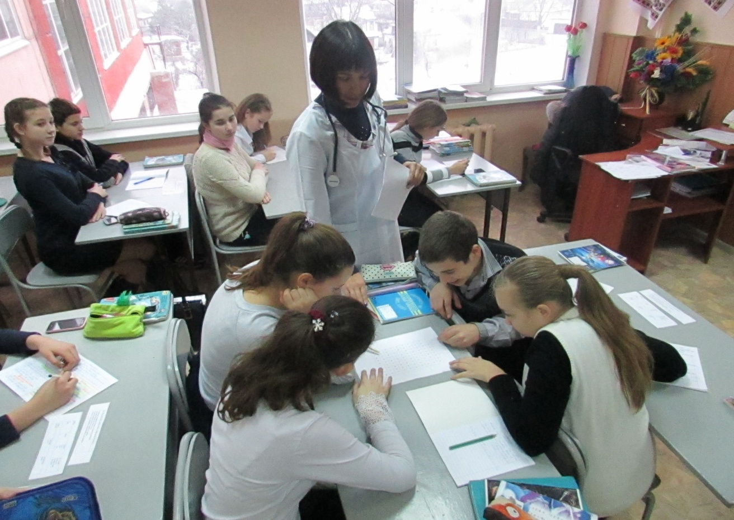

Урок з англійської мови у 7 класі
на тему "Здоров'я - найцінніший скарб"
Вчитель: Іваниця Валентина Ігорівна
Тема уроку: “Health is above wealth’’
Мета уроку:
Практична: Повторити та закріпити лексику теми "Здоров’я”, активізуючи її в усному та писемному мовленн учніві;
Навчальна: навчити вести діалог у лікаря та удосконалювати навички діалогічного мовлення;
Розвивальна: розвивати вміння учнів творчо використовувати засвоєний матеріал в нових ситуаціях спілкування, вміння логічно викладати свої думки та ефективно співпрацювати під час парної , групової та індивідуальної роботи учнів; навчити аудіюванню;
Виховна: виховувати позитивне та дбайливе ставлення до життя та до свого здоров'я.
Тип уроку: узагальнення знань.
Обладнання: підручники, робочі зошити та словники, навчальні картки та таблиці, діалоги, кросворд, записи на дошці.

Xiд уроку
1. Організаційний момент
- Good afternoon, all! Glad to see you! Take your seats, please.
Is anybody absent? What's up? Is she (he) ill?

2. Повідомлення теми і мети уроку
- Thousands years ago ancient Greeks said:” The first wealth is Health. Health is the best Wealth”. These quotation will be the redline of today's lesson.

3. Уведення в іншомовну атмосферу. Мовленнєва зарядка
Т.: -What should you do to be healthy?
Р.1 -You should organize you daily routines.
Р.2 -You should do your morning exercises every day.
P.3 – You should go in for sports.
Р.4 -You should keep clean yourself.
P.5 -You should brush your teeth every day.
Р.6 -You should eat healthy food regularly.
Р.7 -You should visit a doctor if you need.
–Yes, you are right.

4. Перевірка домашнього завдання.
What was your home task for today?
Our home task :-repeat some new words,
- to learn some dіalogues and proverbs about health,
- to do Ex.1p.58 (the units of the hospital).
OK. Let`s check.
1) Let’s repeat our new words (cards with pictures)
2) Tell the proverbs about health, in turn. And translate them, please.
-An apple a day keeps the doctor away.
-After dinner sit a while, after supper walk a mile.
-Early to bed and early to rise makes a man healthy, wealthy and wise.
-Eat at pleasure, drink with measure.
-A healthy man is a successful man.
-Eat to live, not live to eat.
-He, who has health, has hope; and he, who has hope, has everything.
-Prevention is better than cure.
-Good health is above wealth.
-The greatest wealth is health.
-The first wealth is health.
-Health is better than wealth.
3) Match the names of the units with the pictures-schemes (on the blackboard).
…
5) Фізкультхвилинка ‘Hands up’
We are going to have a warm -up! So you should do some exercises.

6) Aктивізація лексичного матеріалу. Діалогічне мовлення.
Рольова гра “У лікарні”

Dialogues

Dialogue 1 (Pediatrician)
-Hello!
-Hello! I’m listening to you. What’s the matter with you?
-I think I have a flu.
-Why do you think so? What are the symptoms?
-I have a high temperature, a headache, a cold, a sore throat and a bad cough.
-I must examine you. I must sound you.
-OK. Take a thermometer for 5 minutes.
-That’s all. What is your temperature?
-39 degrees
-OK I’m agree with you.
-And what is the treatment?
-Now you must go home and stay in bed, drink warm tea, not hot, take some pills and vitamins. And here is the prescription.
-Thank you.
-Not at all. I advise you to stay at home, don’t forget. See you on Monday.
Good bye.
-Good bye.

Dialogue 2 (Dermatologist)
-Hello!
-Hello! I’m listening to you. What’s the matter with you?
-I think I have an allergy.
- Why do you think so? What are the symptoms?
-Yesterday I ate 20 oranges and today I’m sneezing, itching and have some pimples.
-I must examine you. Show me your neck, hands, stomach.
OK I’m agree with you.
-And what is the treatment?
-Now you must take some pills and don’t eat oranges.
And here is the prescription.
-Thank you.
-Not at all. I advise you don’t eat oranges, don’t forget. See you on Monday.
Good bye.
- Good bye.

Dialogue 3 (Dentist)
-Hello!
-Hello! I’m listening to you. What’s the matter with you?
-I have a terrible toothache. I can’t eat, I can’t sleep. Doctor, help me, please!
-I must examine you. Open your mouth
I can help you. Here is an injection with painkiller.
-Thank you.
-Wait 15 minutes.
Open your mouth again. And that’s all. You may go.
-Thank you.
-Not at all. I advise you not to eat during one hour, don’t forget. Good bye.
-Good bye.

Dialogue 4 (Pediatrician)
-Hello!
-Hello! I’m listening to you. What’s the matter with you?
-I have a high temperature and a terrible headache. Five minutes before I had a giddiness.
-I must examine you. Look at me. Oh, it’s a sunstroke.
-And what is the treatment?
-Now you must stay in bed, take some pills and sleep.
And here is the prescription.
-Thank you.
-Not at all. I advise you to stay in bed, don’t forget. See you on Monday.
Good bye.
-Good bye.

Dialogue 5 (Surgeon)
-Hello!
-Hello! I’m listening to you. What’s the matter with you?
-Yesterday in the evening I was running in the park and suddenly I saw a hedgehog and I can’t stop and fell. I had a bleeding. Now my leg is swollen and I think I have a bruise.
-I must examine you. Show me your leg . Oh, it’s a fracture.
Well, I can help you. I’ll make you an injection, then I’ll put you a plaster.
-Thank you.
-Not at all. I advise you to stay at home, don’t walk. See you in three weeks.
Good bye.
-Good bye.

Dialogue 6 (Eye doctor)
-Hello!
-Hello! I’m listening to you. What’s the matter with you?
-I can’t see.
-I must examine you. Open your eyes.
-I can’t
-Oh, you really have problems with your eyes. It’s a conjunctivitis.
-And what is the treatment?
-Now you must stay at home, take some pills and vitamins and drop your eyes. And here is the prescription.
-Thank you.
-Not at all. I advise you to stay at home, don’t forget. See you on Monday.
Good bye.
-Good bye.

Dialogue 7 (pediatrician )
-Hello!
-Hello! I’m listening to you. What’s the matter with you?
-I think I have something terrible.
-Why do you think so? What are the symptoms?
-I always itch and have a lot of little pimples and the temperature is very high.
-I must examine you. Show me your body.
-OK I’m agree with you. You have a smallpox.
-And what is the treatment?
-Now you must take some pills and put the pimples with viridity (viride nitens).
And here is the prescription.
-Thank you.
-Not at all. See you in two weeks. Good bye.
- Good bye.

---Who am I? (in every dialogue)
7) Активізація лексичних одиниць.
а) ( Робота в парах)
Put the words in the correct order to make up the sentences:
1) diseases, medicines, People, to treat, use, different.
2) cured, illnesses, be, Most, can.
3) are, hospitals, Serious, treated, in, injuries.
4) have, every, checkups, Schoolchildren, year, medical.

в) ( Робота в групах )

-Now children you have to work with these crosswords. You’ll find all necessary words. Let`s divide into groups.

P | A | T | I | E | N | T | U | W
A | X | O | Y | A | O | M | F | N
I | F | O | B | R | S | T | I | U
N | A | T | B | A | T | C | N | D
E | Q | H | D | C | O | U | G | H
B | M | A | O | H | E | R | E | E
L | S | C | C | E | S | K | R | A
O | K | H | T | K | L | M | O | L
O | N | E | O | P | S | F | I | T
D | T | H | R | O | A | T | P | H

Key – words: patient, pain, toothache, earache, cough, health, fit, doctor, throat, blood, finger, toe.
с) Ex.4 p.60 (In your copybooks, put the sentences in the correct order and read about the physical examination)

9) Підведення підсумків. Виставлення оцінок. (tables)

During the lesson we have spoken a lot about different doctors and our health.
-What should you do to be healthy?
-What doctors do when you visit them?

Table 1

I  WE | should | brush  eat  do  go | for a walk  exercises  healthy food  the teeth

Table 2

Doctors | examine  write | prescription  body

And now your marks…

10) Оголошення та пояснення домашнього завдання.
Open your daybooks and write down your hometask.
Your hometask is Ex.3 p.70 (read and translate the text “Biorhythms’’)

Our lesson is over.
Good-bye.

ДОДАТКИ

Table 1
I  WE | should | brush  eat  do  go | for a walk  exercises  healthy food  the teeth

Table 2
Doctors | examine  write | prescription  body

Table 1
I  WE | should | brush  eat  do  go | for a walk  exercises  healthy food  the teeth

Table 2
Doctors | examine  write | prescription  body

Table 1
I  WE | should | brush  eat  do  go | for a walk  exercises  healthy food  the teeth

Table 2
Doctors | examine  write | prescription  body

P | A | T | I | E | N | T | U | W
A | X | O | Y | A | O | M | F | N
I | F | O | B | R | S | T | I | U
N | A | T | B | A | T | C | N | D
E | Q | H | D | C | O | U | G | H
B | M | A | O | H | E | R | E | E
L | S | C | C | E | S | K | R | A
O | K | H | T | K | L | M | O | L
O | N | E | O | P | S | F | I | T
D | T | H | R | O | A | T | P | H

Робота в групах: Скласти діалог, який розрізаний на стрічки. Команда, яка першою правильно складає діалог, зачитує його в голос за ролями.
• Good morning, Doctor Benson. Can you help me?
• What’s the matter with you, Mr. Brown? I see you have taken your temperature. What is it?
• It’s 38,7(thirty eight point seven). And I feel bad, I’ve got a headache and sore throat. It hurts when I swallow/ Besides, I’m afraid; I have got pain in my side.
• Let me examine your side. Everything will be all right! Does it hurt when I press here?
• Oh, yes. It is terribly painful.
• Don’t worry. Now I’ll write you out a prescription for some pills and a mixture. I believe that some injections of glucose will also do you a lot of good.
• When shall I come next time, Doctor?
• I think, in four days. Good-bay, Mr. Brown.
• Good-bye, Doctor. Thanks a lot.
Put the words in the correct order to make up the sentences:
1) diseases, medicines, People, to treat, use, different.
2) cured, illnesses, be, Most, can.
3) are, hospitals, Serious, treated, in, injuries.
4) have, every, checkups, Schoolchildren, year, medical.

Put the words in the correct order to make up the sentences:
1) diseases, medicines, People, to treat, use, different.
2) cured, illnesses, be, Most, can.
3) are, hospitals, Serious, treated, in, injuries.
4) have, every, checkups, Schoolchildren, year, medical.

Конкурс проектних робіт
між учнями
6-х класів
на тему “My family”
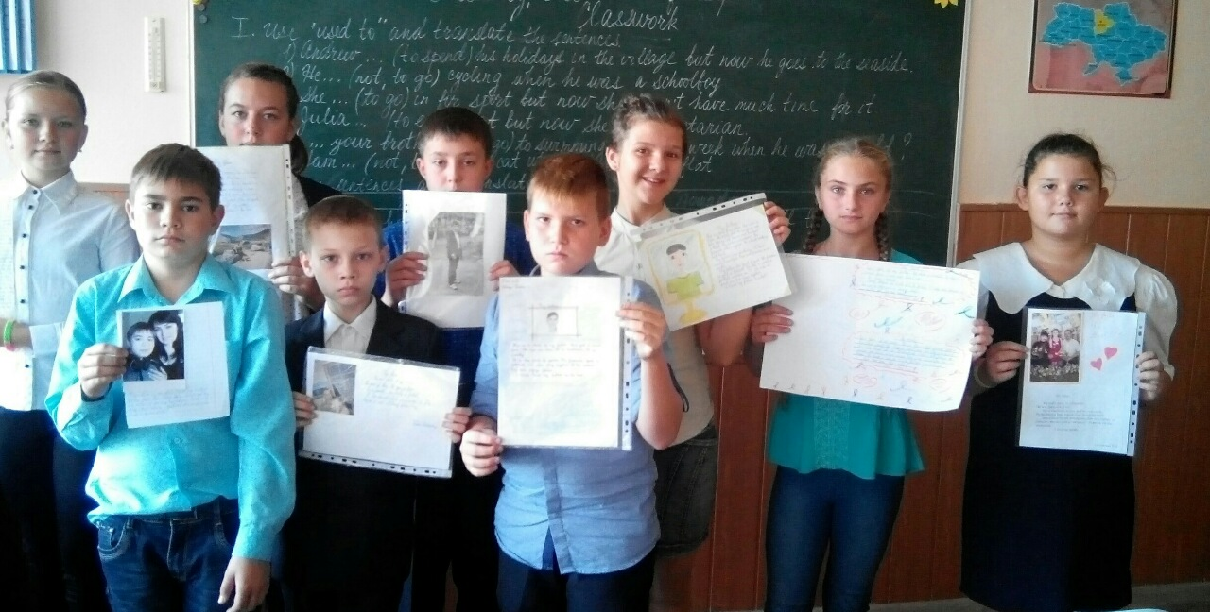

Конкурс проектних робіт у 10 класі
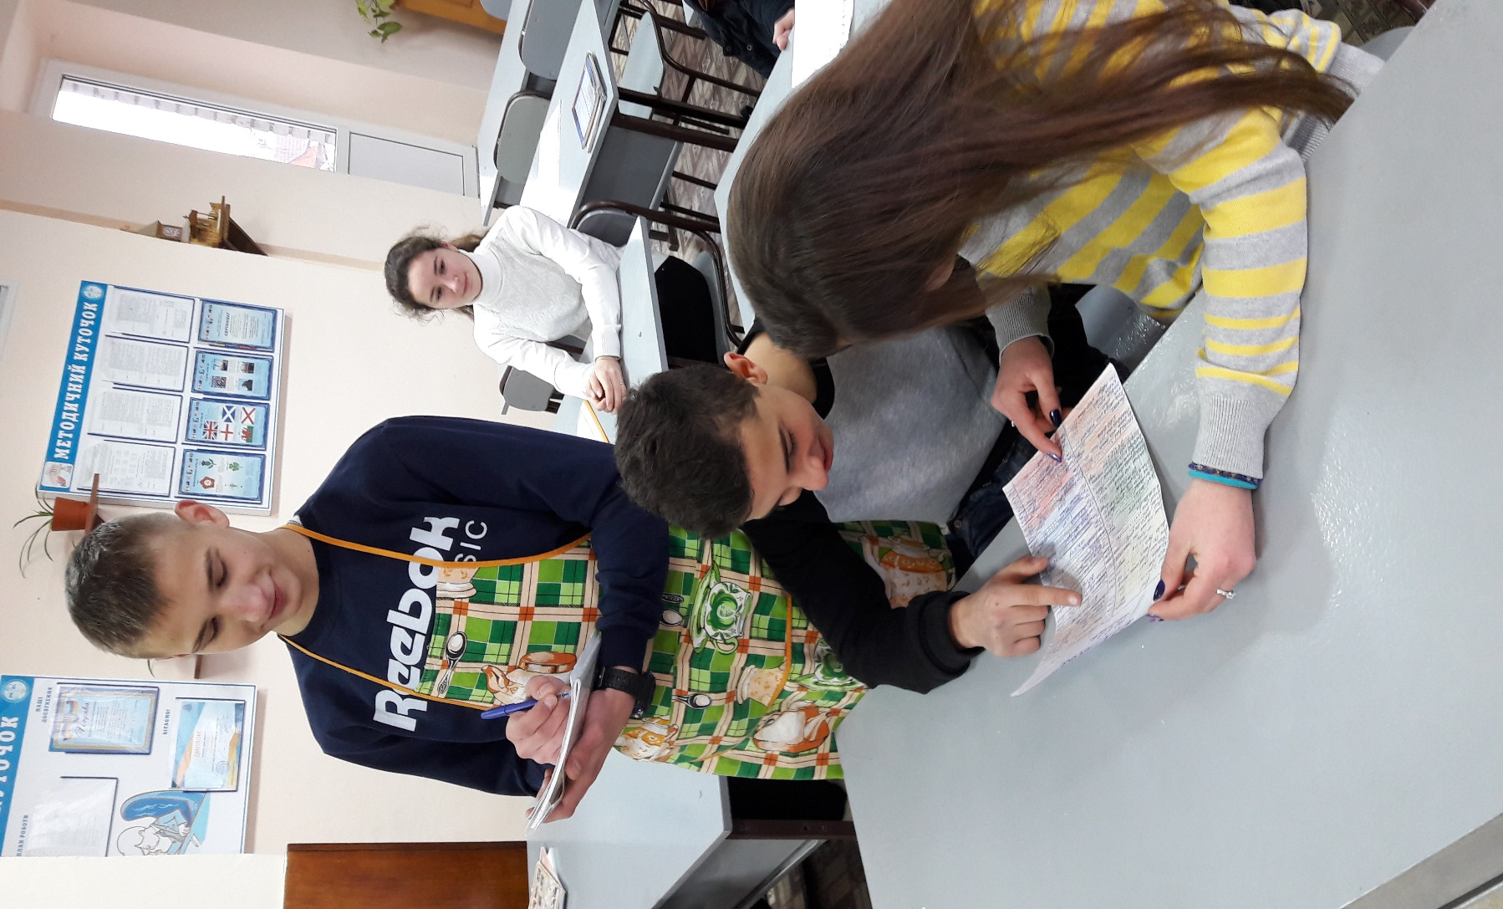
на тему : «Меню мого ресторану»

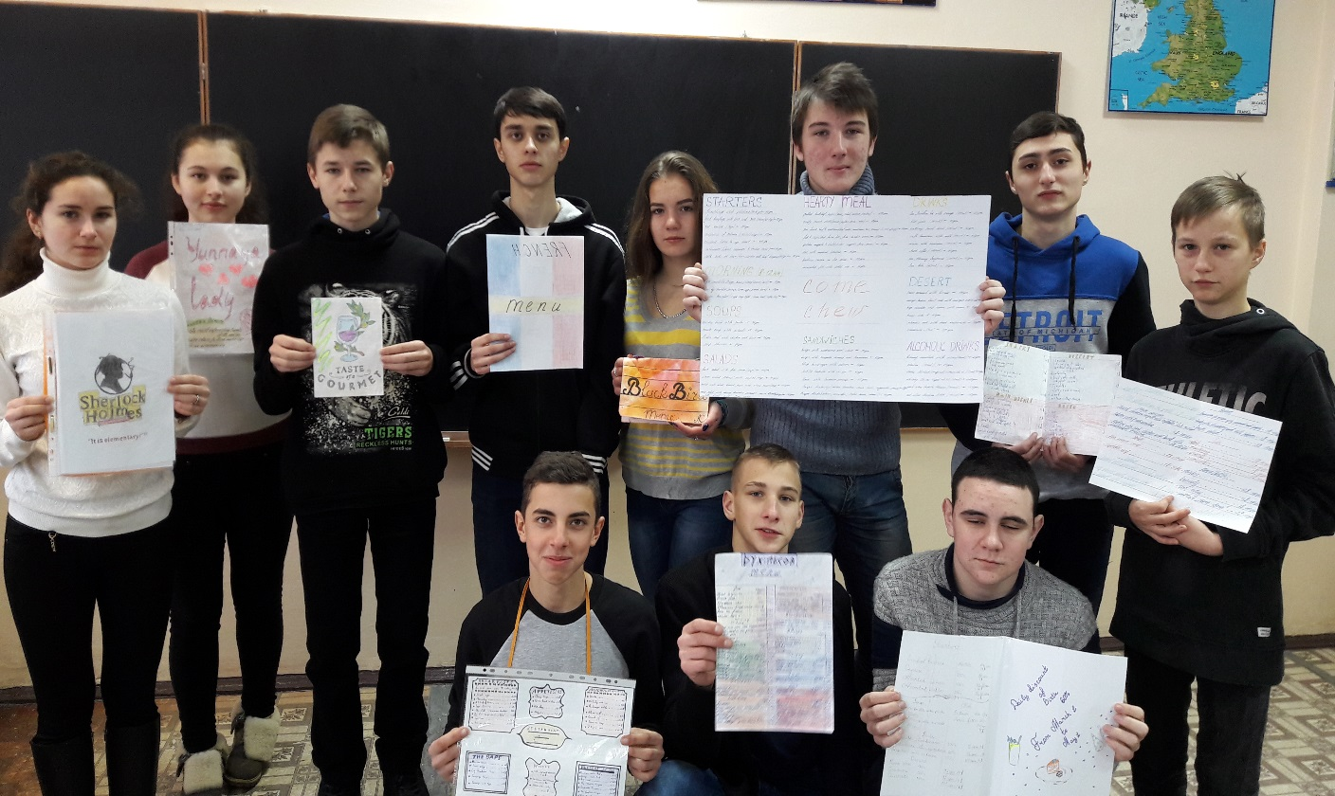

Конкурс проектних робіт між учнями 8-х класів
на тему : «Шкільна газета»
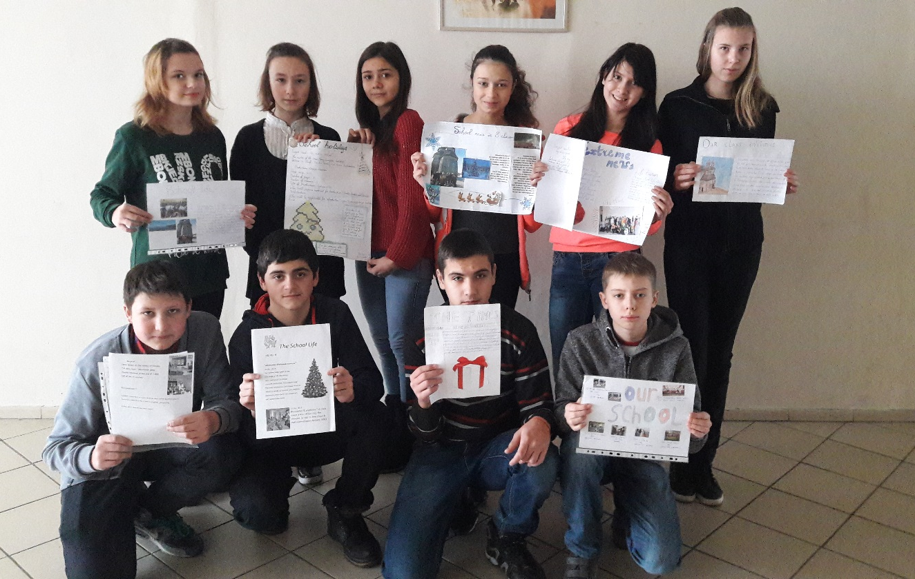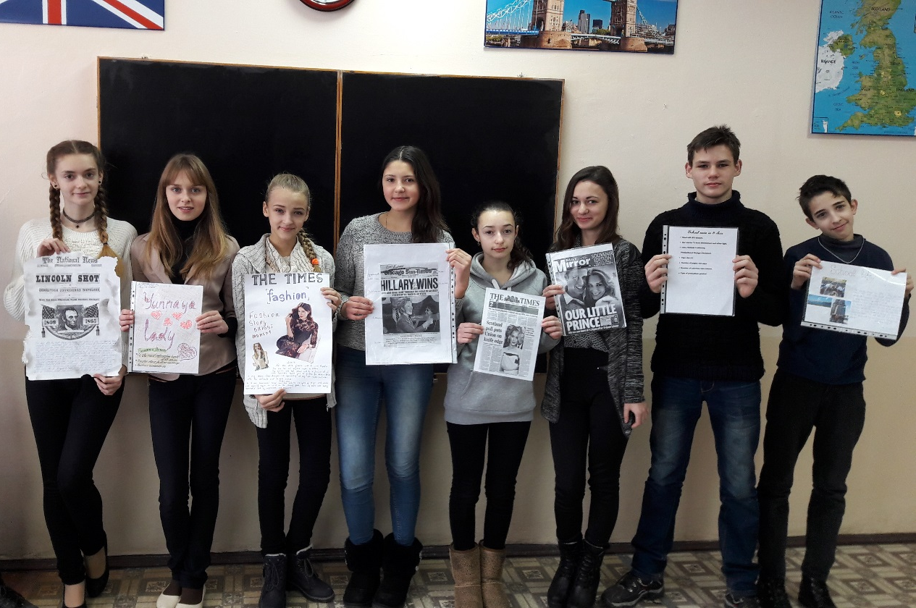

Конкурс проектних робіт
між учнями 7 – х класів
на тему: «Медицина»

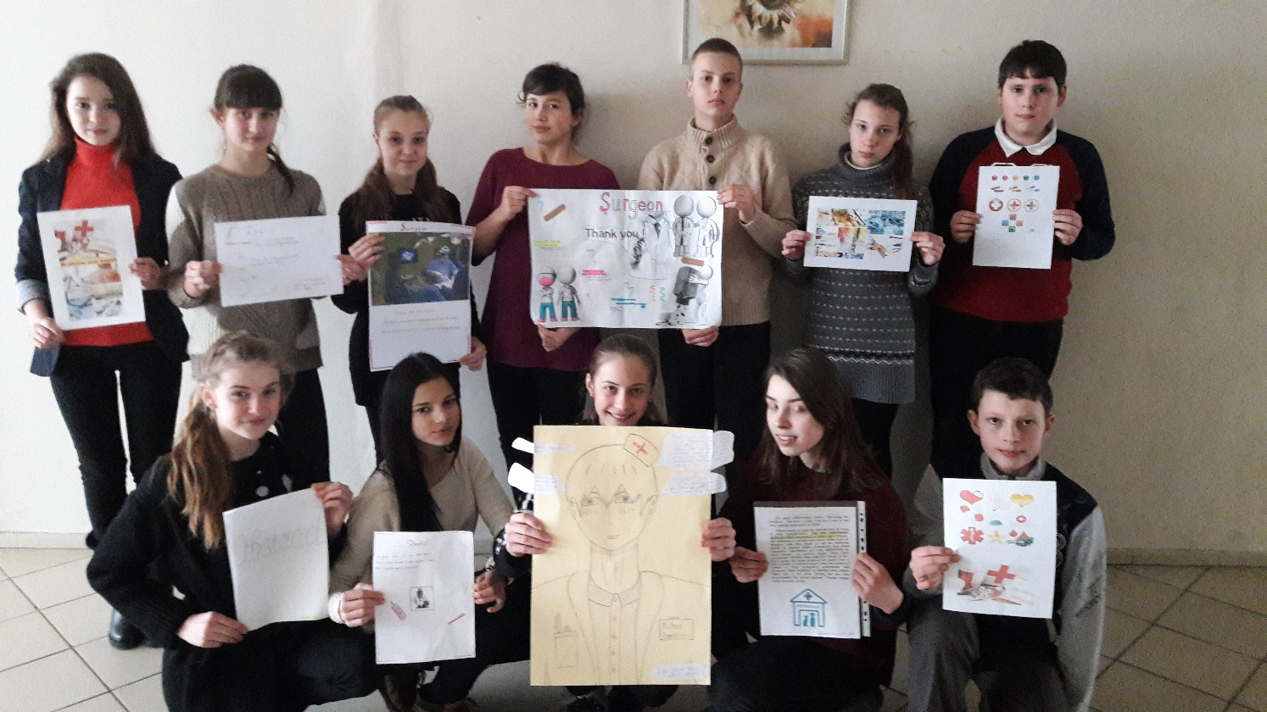

Позакласний захід у 8-А класі
на тему: «Ромео і Джульєта»
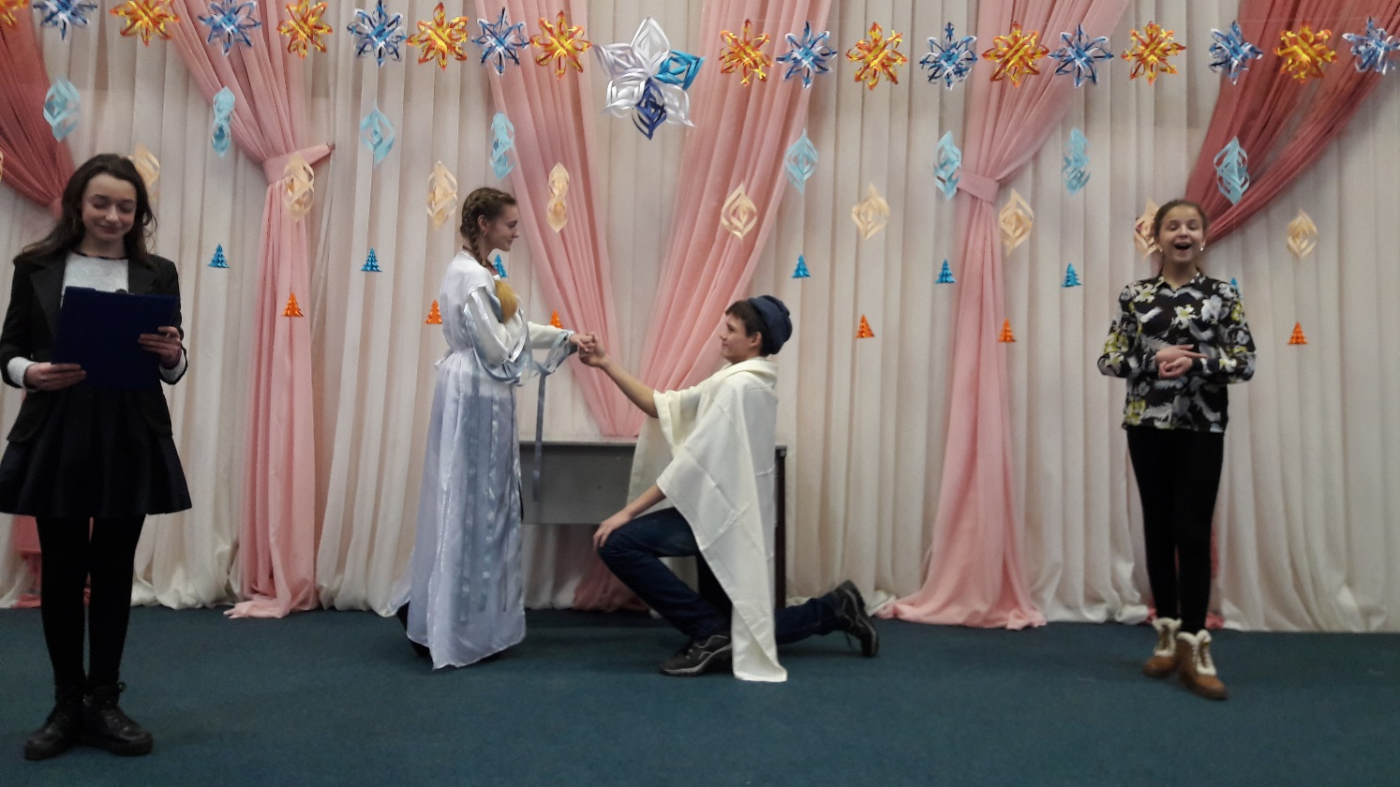
вчитель : Крохмаль Любов Іванівна

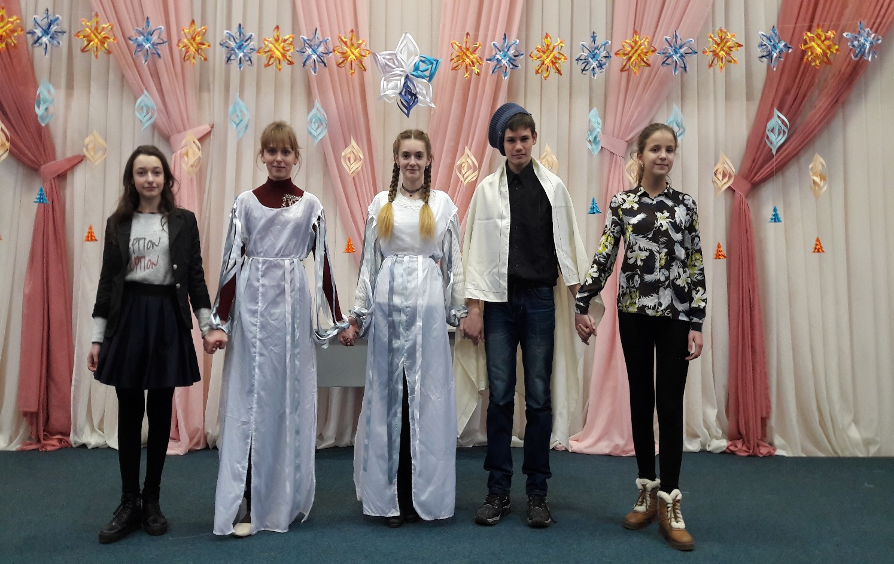

Комунальний заклад освіти
«Спеціалізована школа №115»
Дніпропетровської міської ради

Позакласний захід у 8-А класі
на тему: «Romeo and Juliet»

Підготувавала: вчитель англійської мови
Крохмаль Любов Іванівна

2016-2017н.р.

Мета:
- Ознайомити учнів з життям і творчістю великого поета, деякими його сонетами в оригіналі і перекладах;
- Практикувати навички монологічного мовлення;
- Тренувати уміння виразного читання сонетів,
- Розвивати комунікативні компетенції,
- Виховувати любов до літератури країни мови, що вивчається;
- Розвивати естетичний смак.
- Розвивати вміння учнів приймати участь в драматизації вистав
Обладнаня: портрет В. Шекспіра, комп’ютер, проектор, екран.
Хід заходу:
Compere 1: It is midnight but nobody wants to sleep. Words, phrases overwhelm the mind, the heart. Someone wants to write everything, someone doesn`t want to miss anything… Everything is important. May be in such a way William Shakespeare from England forgot about the time and noisy company of friends-actors who had been celebrating the end of the performance.
Compere 2: Дванадцята година ночі, а спати зовсім не хочеться. Слова і фрази переповнюють ум і серце, і все хочеться занотувати, нічого не пропустити… Все важливо, все необхідно… Можливо, так, забувши про все і залишивши галасливу компанію друзів-акторів, які святкують закінчення чергового спектаклю, не помічаючи плину часу, багато-багато років тому в далекій Англії творив свої безсмертні п’єси великий Вільям Шекспір.
Compere 4: «All the world is a stage»; «To be or not to be? That is a question». These quotations are from Shakespeare`s plays are known all over the world. The last half of the 16th and the beginning of the 17th centuries are the Golden Age of the English literature. It was the time of the English Renaissance, and sometimes is called «The Age of Shakespeare». It is the time of ladies and cavaliers.
Compere 1: «Весь світ – театр», «Бути чи не бути? Ось у чому питання» Це всесвітньо відомі вислови. Друга половина 16 ст. і поч.. 17 ст. – це «Золота доба англійської літератури». Це був час Англійського Ренесансу, який іноді називають епохою Шекспіра. Це час придворних дам і кавалерів, реверансів і менуетів.
Compere 2: William was born on April, 23, 1564, in the town of Stratford-on-Avon. His father, John Shakespeare, a dealer of wool and leather. He was respected figure in Stratford. His mother, Mary Arden, was the daughter of local, land-owner. In his childhood William went to the Stratford grammar school.
Compere 3: When Shakespeare was 18 he married Anne Hathaway, a farmer`s daughter, who was eight years older than himself. In 1583 Susanna, their first child, was born and then twins, Hamlet and Judith. Later Shakespeare left for London.
Compere 4: В. Шекспір народився 23 квітня 1564 року у місті Стретфорді-на-Ейвоні. Його батько, Джон Шекспір, був продавцем вовни і шкіри. Його поважали у місті. Мати, Мері Арден, була дочкою місцевого землевласника. В дитинстві Шекспір відвідував Стретфордську граматичну школу. У віці 18 років він одружився на дочці фермера, Анні Хетевей, яка народила йому дочку Сузанну та Близнюків, Юдифа та Гамлета. Пізніше Шекспір від’їжджає до Лондона.
Compere 1: In London Shakespeare became the playwright of the famous Globe Theatre. He was also an actor, but obviously not a first-rate one. But Shakespeare`s experience as an actor helped him in the writing of his plays.
Compere 2: Although London was Shakespeare`s home, but he often visited Stratford-on-Avon, where his family continued to live. In 1597 he bought the largest house in Stratford. And the last years of his life he spent in his native town. William Shakespeare died in his birthday on the 23d of April, 1616 when he was 52. He was buried in the church of Stratford. Four lines are inscribed on it.
Good friend, for Jesus’ sake forbear
To dig the dust enclosed here.
Blest be the man that spares these stones
And curst be he that moves my bones.
Compere 3: В Лондоні Шекспір став драматургом відомого театру «Глобус». Також, він був актором, а от головних ролей не грав. Але акторський досвід Шекспіра дуже допоміг йому у написанні п’єс.
Хоча Лондон став йому домом, він часто відвідував Стретфорд-на-Ейвоні, де продовжувала жити його сім’я. У 1597 році він купив найбільший будинок у Стретфорді. Останні роки свого життя він провів у рідному містечку.
Помер Вільям Шекспір 23 квітня 1616, у день свого народження, коли йому виповнилося 52 роки. За волею самого драматурга його поховано у Стретфордській церкві, а не у Вестмінстерському Абатстві. Чотири рядки висічено на його могильній плиті: «Добрий друже, в ім’я Ісуса, не вилучай праху похороненого тут. І благословенний нехай буде той, хто не торкнеться каміння. Нехай буде проклятий той, хто потурбує мої кості».
Shakespeare. My dear friend, I decided to write the play «Romeo and Juliet» about love of two young people. This is the anthem of great feelings. Their families are the biggest enemies. The end of this play is unexpected. Romeo and Juliet die. Now this play is very popular.
Compere 4: «Мій друже! Я написав п’єсу «Ромео і Джульєтта» про любов двох молодих людей з ворогуючих сімей. Це – справжній гімн великим почуттям. Зараз ця п’єса стала дуже популярною.
Compere 1: The two chief families in Verona werethe Capulets and the Montagues, both veiy rich families.An old quarell between these two families had grown toa great height.
Compere 2: And they were such enemies that even their followers and servants could not meet without fierce words, which sometimes caused blood to run.
Compere 3: Once old Lord Capulet gave a great supper. All the beauties of Verona were present, except the house of Montague.
Compere 4: So to your attention some scenes from Romeo and Julliet by W. Shakespeare.
Compere 1: Great supper in the house of Capulet.
Capulet: Oh, young people you are welcome to our party. There are plenty of ladies for you to dance with.
Romeo: Great thanks. Who are you a beautiful girl?
Juliet: I'm Juliet
Romeo: Oh, I haven't seen you before. Your beauty shows by night like a rich jewel. Your beauty is rich for use, too dear for early. You are a white bird among black ones. Your beauty dear Julliet and your perfection's shine above all other ladies.
Compere 2: You see Tybalt the nephew of Lord Capulet, he has quick and angry temper. Suddenly he knows Romeo by his voice.
Tybalt: Dear ladies and Gentlemen! This dirty Montagne comes here under cover of mask to make fun of us at our feast.
Romeo: Oh, Julliet you are a holy place, which I do wrong to touch. I'm a humble pilgrim and will I kiss you to repair the wrong.
Juliet: Good pilgrim! Saints have hands, which pilgrims may touch, but not kiss.
Romeo: Have not saints lips and pilgrims too?
Juliet: Yes, lips which then must use in prayer.
Romeo: May I invite you for dance.
Juliet: With great pleasure.
Romeo: And who is your mother?
Juliet: I'm a daughter of a rich lord Capulet, the great enemy of Montagues.
Romeo: What? But I'm a son of Montague. So, bye! What can I do? She is a daughter of our enemy and I have given my heart to a member of that family.
Juliet: Romeo is a Montague and I have been suddenly struck with love for him. It is a wonderful birth of love, but I shall love for my enemy.
Compere 3: So, this morning, Romeo and Juliet joined their hands in holly marriage. The good friar prayed that the heavens will smile upon this act and that the union of young, Montague and young Capulet will end forever the old quarrel between their families.
Compere 4: But this day there was a quarrel between Tybalt and Benvolia with Mercutcio and Romeo. Mercutcio was killed and Romeo kept his temper no longer. He killed Tybalt. Romeo was ordered to leave Verona.
Lord Capulet: Dear daughter I have chosen for you a young man for marriage. It is count Paris, a brave young and noble gentleman. He will be a suitable husband for you.
Juliet: Oh, dear father I'm very young to marry.
Lord Capulet: No! Say me nothing, It is my decision.
Juliet: But I'm too weak to meet a husband with the face of joy, because of recent death of Tybalt.
Lord Capulet: Dear Juliet I'm deaf to all your excuses and I order you to get ready for marriage by the next Thursday.
Juliet: My only love sprung from my only hate!
Too early seen unknown, and known too late!
Prodigious birth of love it is to me,
That I must love a loathed enemy.
Romeo: Now old desire doth in his deathbed lie,
And young affection gapes to be his heir;
That fair for which love groan’d for, and would die,
With tender Juliet match’d, is now not fair.
Juliet: O Romeo, Romeo! wherefore art thou Romeo? Deny thy father and refuse thy name; Or, if thou wilt not, be but sworn my love, And I’ll no longer be a Capulet.
Romeo: What’s Montague? It is nor hand, nor foot, Nor arm, nor face, nor any other part Belonging to a man. O, be some other name! What’s in a name? That which we call a rose By any other name would smell as sweet;
Romeo: Call me but love, and I’ll be new baptized.
Henceforth I never will be Romeo.
My name is hateful to myself
Because it is an enemy to thee.
Compere 1: A glooming peace this morning with it brings.
The sun for sorrow will not show his head.
Compere 2: Go hence, to have more talk of these sad things;
Some shall be pardon'd, and some punished;
Compere 3: For never was a story of more woe
Than this of Juliet and her Romeo.

Брейн-ринг між 3-ми класами
